
Statistics Mini Project

Unlocking Customer Insights:

A Statistical Investigation

November 7, 2025

Student: Sumeet Mehta
Data Science Batch: 10601

Project Title
Unlocking Customer Insights: A Statistical Investigation

Activities:
Apply descriptive statistics, exploratory data analysis, visualizations, and hypothesis testing to investigate behavioral patterns, spending trends, and demographic influences in a real-world customer dataset.

Business Problem Statement:
A mid-sized Indian retail company is sitting on a treasure trove of customer data — but lacks clarity on what story it tells. They need a team of analysts to conduct a rigorous statistical investigation to validate business assumptions, uncover hidden patterns, and support data-driven decision-making.

As a data analytics, you have been tasked with:
● Using statistical tools to explore and summarize the dataset
● Comparing customer behavior across demographic segments
● Testing business hypotheses using statistical methods

Key Goals:
● Analyze customer demographics and behavior using descriptive statistics
● Visualize spending, frequency, and demographic attributes
● Segment customers using appropriate quantitative logic
● Test statistical hypotheses around:
● Age and spending
● Gender and transaction frequency
● Geography and engagement
● Deliver clear, statistically valid insights

Dataset Description
You are provided with a synthetic dataset of 10675 rows for roughly 1,000 unique customers. The dataset exhibits Behavioral Signals like Spending habits, interaction recency, and lifestyle choices like pet ownership

The dataset description:

Column Name | Description
CustomerID | Unique identifier for each customer
Name | Full name of the customer (US names used)
State |  | US state where the customer resides
Education |  | Highest level of education attained (High School to PhD)
Gender |  | Gender identity (Male, Female, Non-Binary)
Age |  | Age of the customer (between 18 and 80)
Married |  | Marital status: Yes or No
NumPets |  | Number of pets owned by the customer (0 to 4)
MonthlySpend |  | Amount spent monthly in USD, generated using a skewed Gamma distribution
DaysSinceLastInteraction |  | Number of days since last interaction with the company

Step-by-Step Investigation Plan
Note: Wherever Statistical Computation is applicable, you will need to use Python and associated libraries

Step 1: Understand Your Data
Business Purpose: Familiarize yourself with who your customers are and what attributes are available to you.
● Load and preview the dataset.
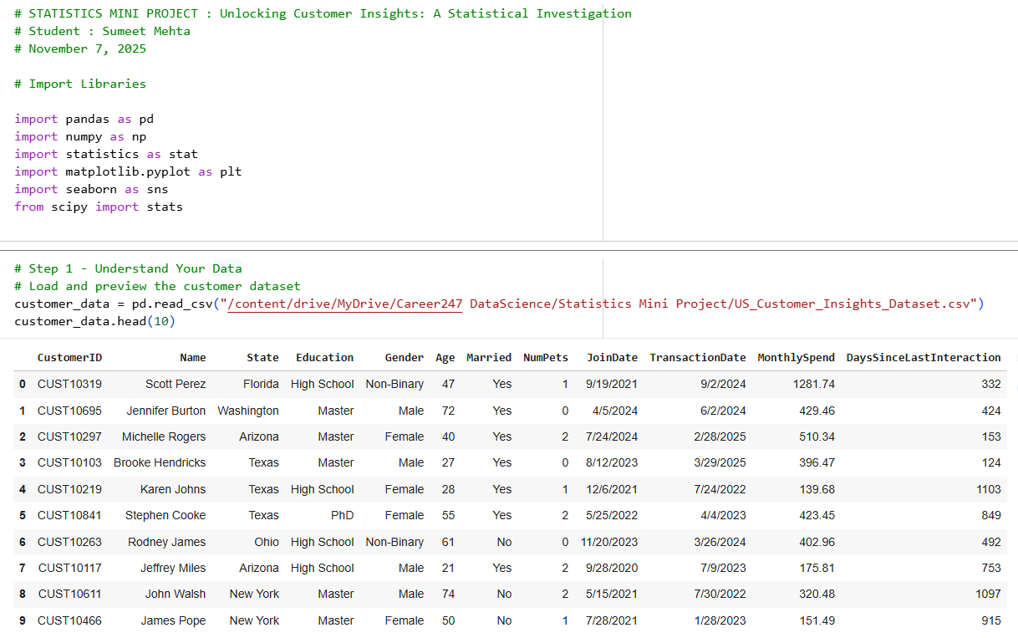

● Check data types, unique values, and presence of nulls.
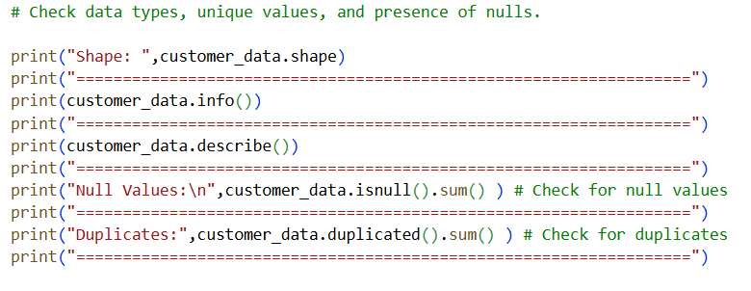
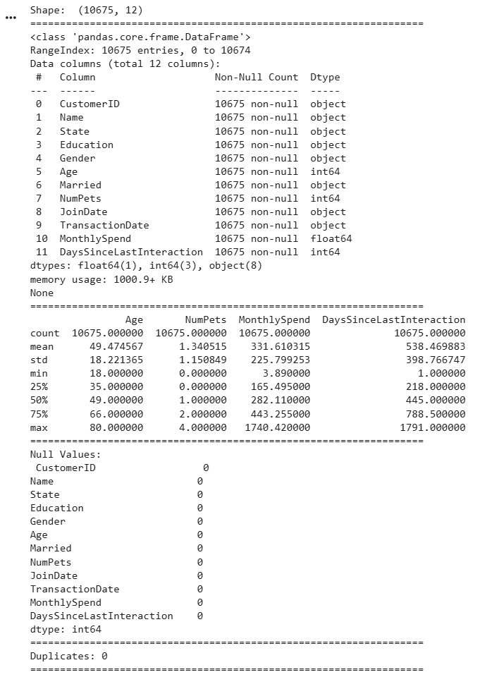
● Understand which variables are categorical and which are numerical.
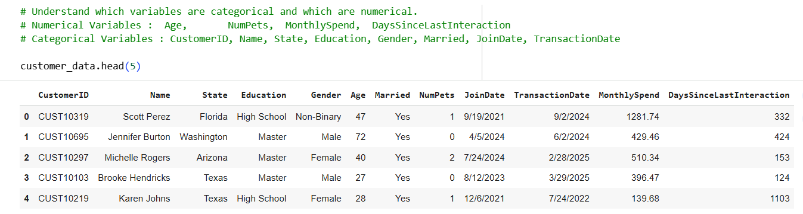

Step 2: Descriptive Statistics
Business Purpose: Describe your customer base — how old are they, how much do they spend, are they active?
● Compute: Mean, median, std dev for Age, MonthlySpend, DaysSinceLastInteraction
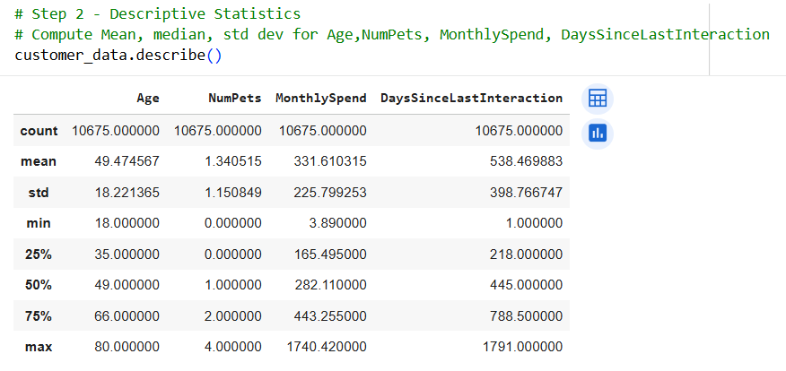
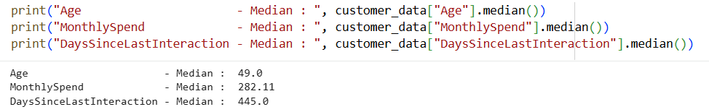
● Mode for categorical variables: Gender, Education, Married
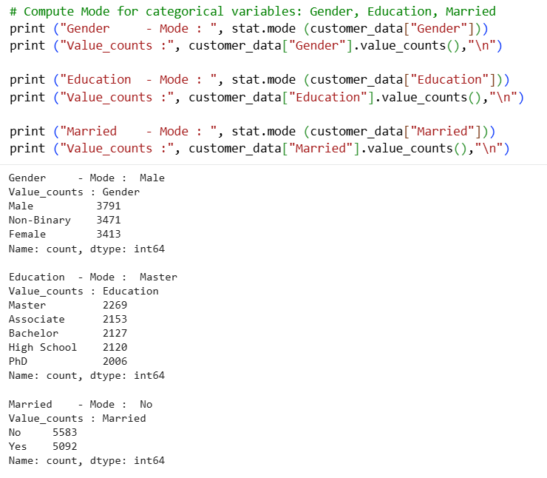

Step 3: Data Visualization
Business Purpose: Reveal patterns that numbers alone can’t show.
● Plot histograms and boxplots for Age, MonthlySpend
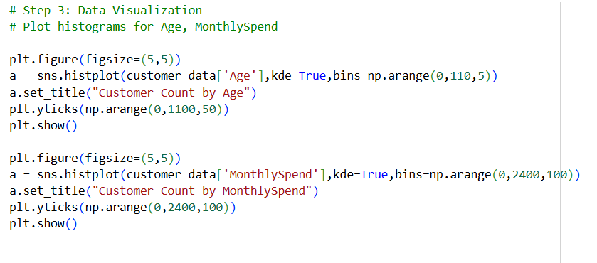
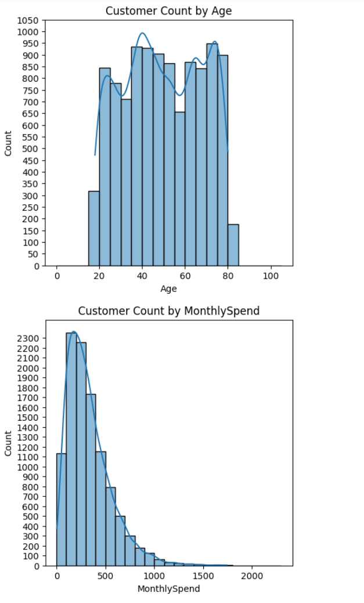

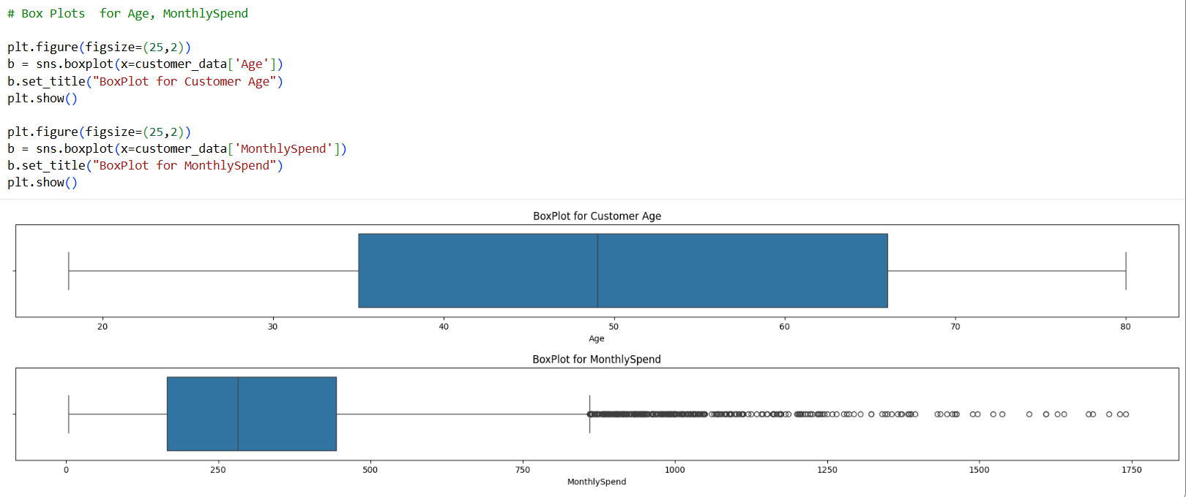

● Create a bar chart for Gender and Education
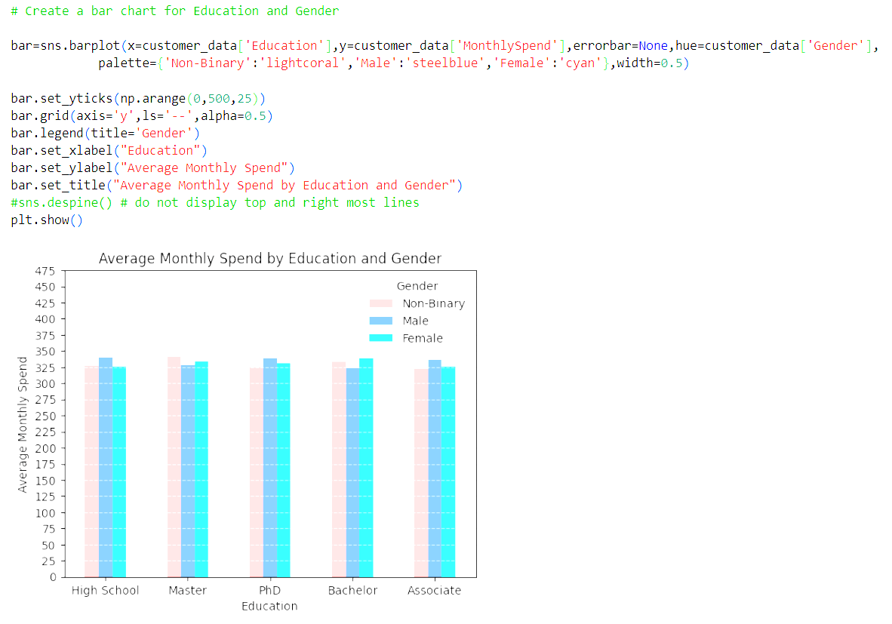
● Create a bar chart for Gender and State
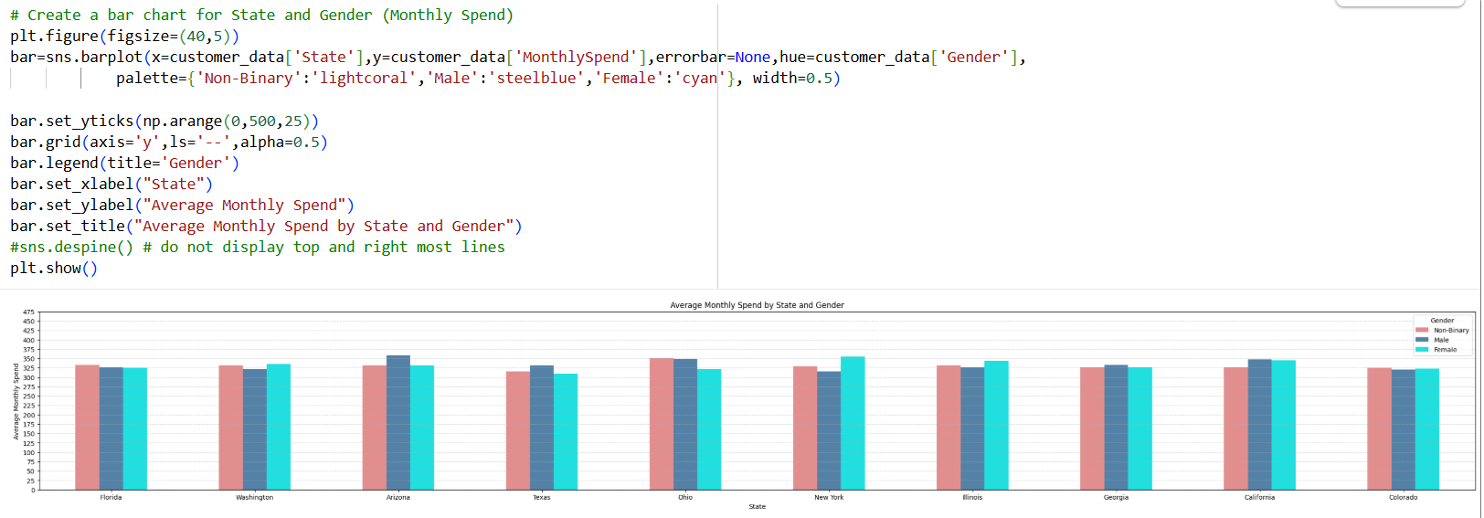

● Scatterplot: Age vs MonthlySpend
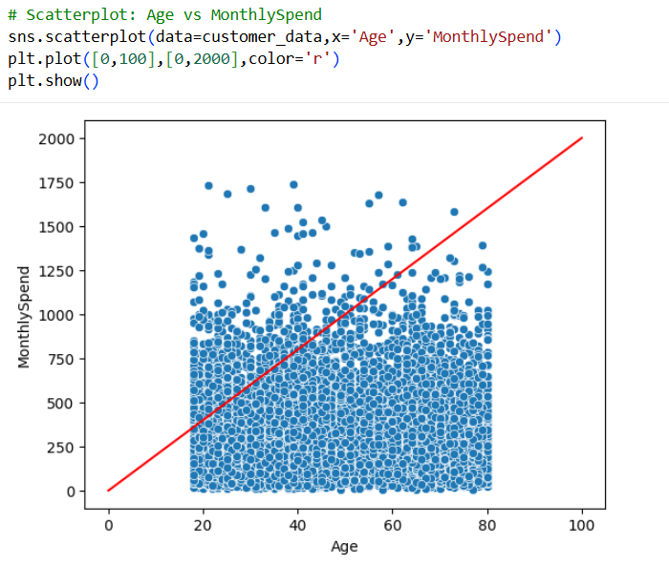

● KDE: Spending behavior by education level or marital status
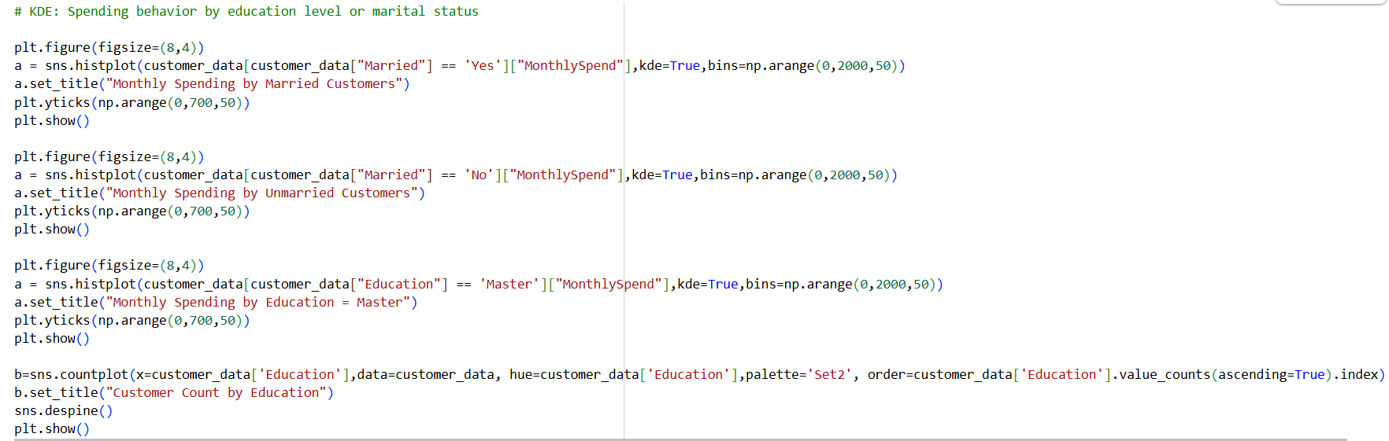

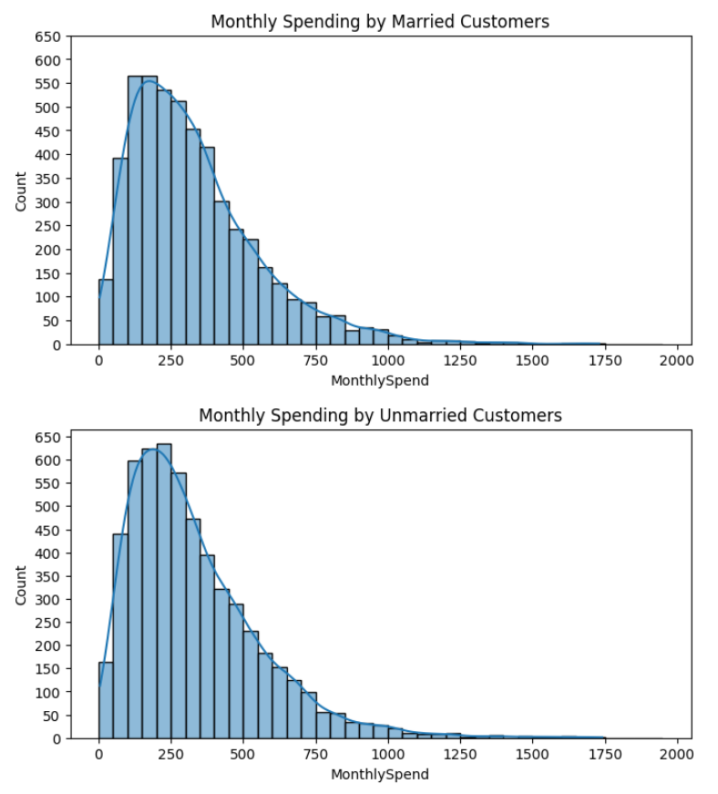
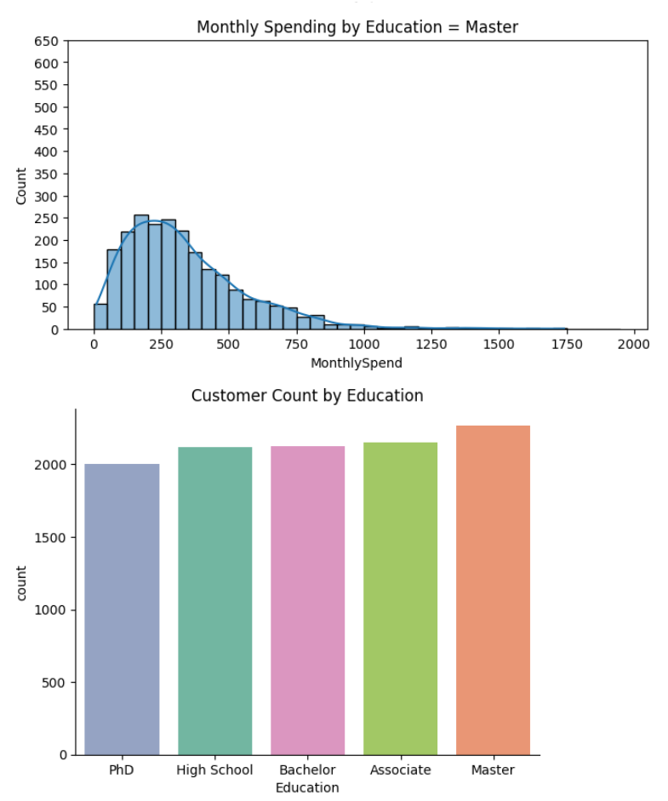

Step 4: Bivariate Analysis
Business Purpose: Check how customer attributes relate to one another.
● Correlation matrix (numeric variables)
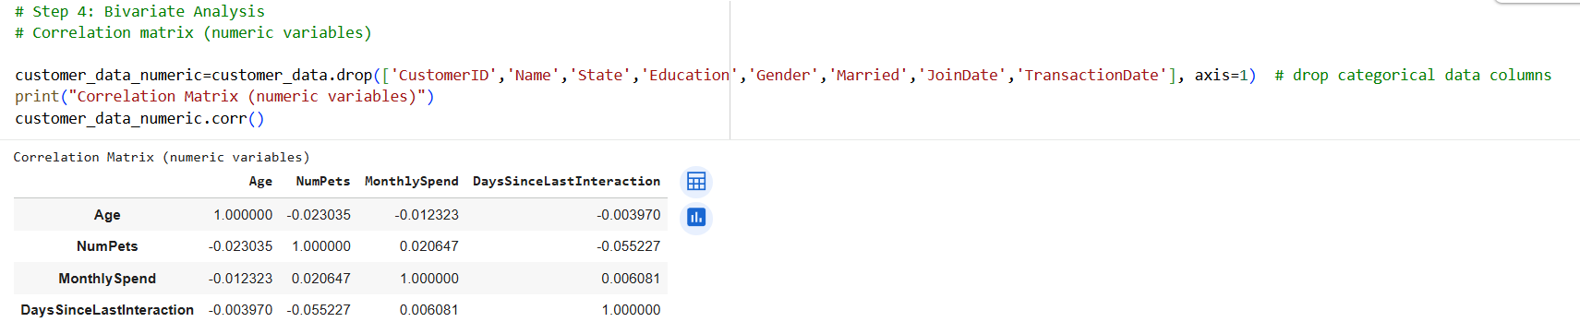
There is weak (very low) correlation between the numeric variables

● Crosstab of Gender vs Married
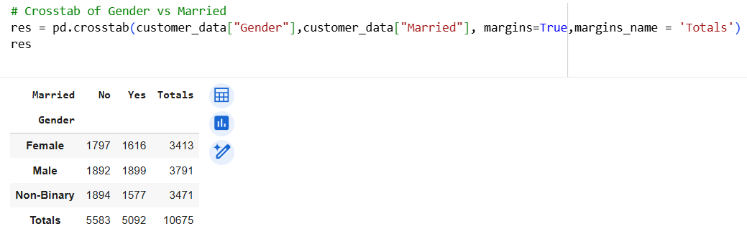
● Grouped stats: average MonthlySpend by State, Education, Gender
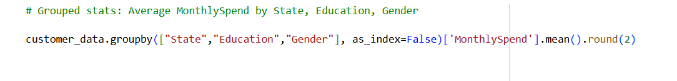
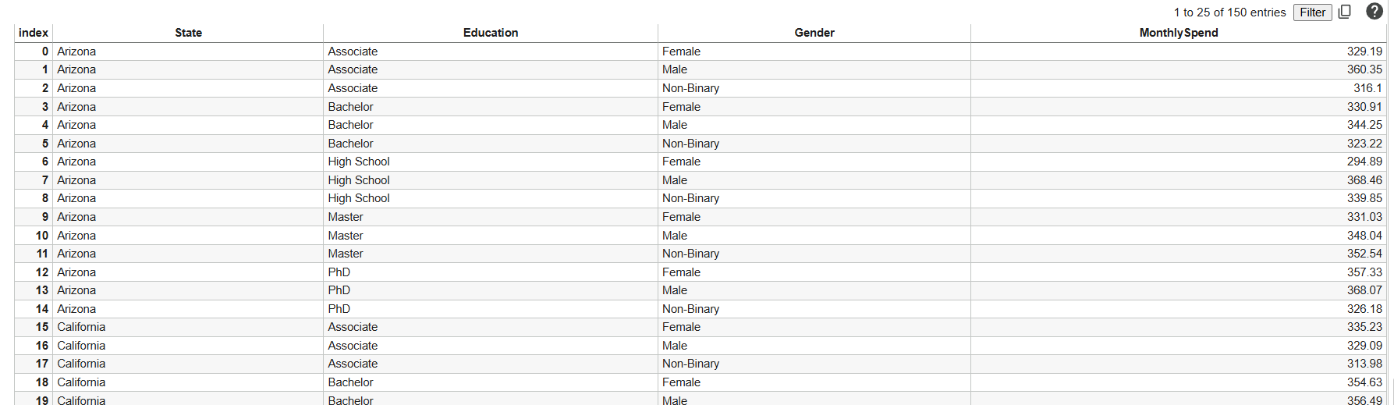

Step 5: Formulate Hypothesis
Business Purpose: Turn business questions into statistical tests.
Business Purpose: Turn business questions into statistical tests. Business Question | Statistical Test
Do males and females spend differently? | Independent t-test
Does education level impact average monthly spend? | One-way ANOVA
Is marital status related to the number of pets owned? [Only for DS Students] | Chi-square test
Are older people less active? | Correlation (Age vs DaysSinceLastInteraction)
Does state-wise spend vary significantly? | ANOVA

Do males and females spend differently? # Independent t-test
Null Hypothesis(H₀): Males & Females spending is similar.
Alternate Hypothesis(H₁): Males & Females spending is different.

Does education level impact average monthly spend? # One-way ANOVA test
Null Hypothesis(H₀): Average monthly spending by Education level is similar.
Alternate Hypothesis (H₁): Average monthly spending by Education level is NOT similar.

Is marital status related to the number of pets owned? [Only for DS Students] # Chi-squared test
Null Hypothesis (H₀): Marital status is related to the Number of Pets.
Alternate Hypothesis(H₁): Marital status is NOT related to the Number of Pets.

Are older people less active? #Correlation (Age vs DaysSinceLastInteraction)
Null Hypothesis (H₀): Older people are less active.
Alternative Hypothesis (H₁): There is no significant correlation between Age and the days since last interaction.

Does state-wise spend vary significantly? # ANOVA
Null Hypothesis (H₀): The means of MonthlySpend across the States are equal.
Alternative Hypothesis (H₁): The mean of MonthlySpend for at least one State varies significantly.

Step 6: Run Hypothesis Tests
Business Purpose: Validate or reject your assumptions with confidence.
● Define null and alternate hypotheses
● Choose test based on data types
● Check assumptions: normality, independence, homogeneity of variance
● Interpret p-values and confidence intervals

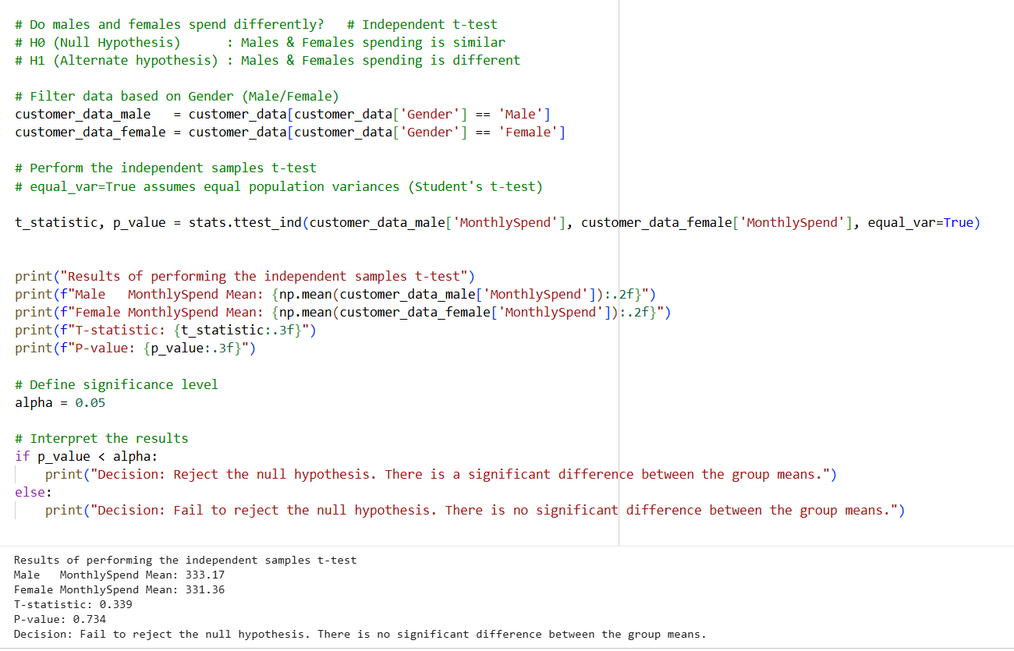
Do males and females spend differently? # Independent t-test
Null Hypothesis(H₀): Males & Females spending is similar.
Alternate Hypothesis(H₁): Males & Females spending is different.

Decision: Fail to reject the null hypothesis as there is no significant difference between the group means based on gender. P-value of 0.734 is > 0.05 and T-statistic = 0.339.

=====================

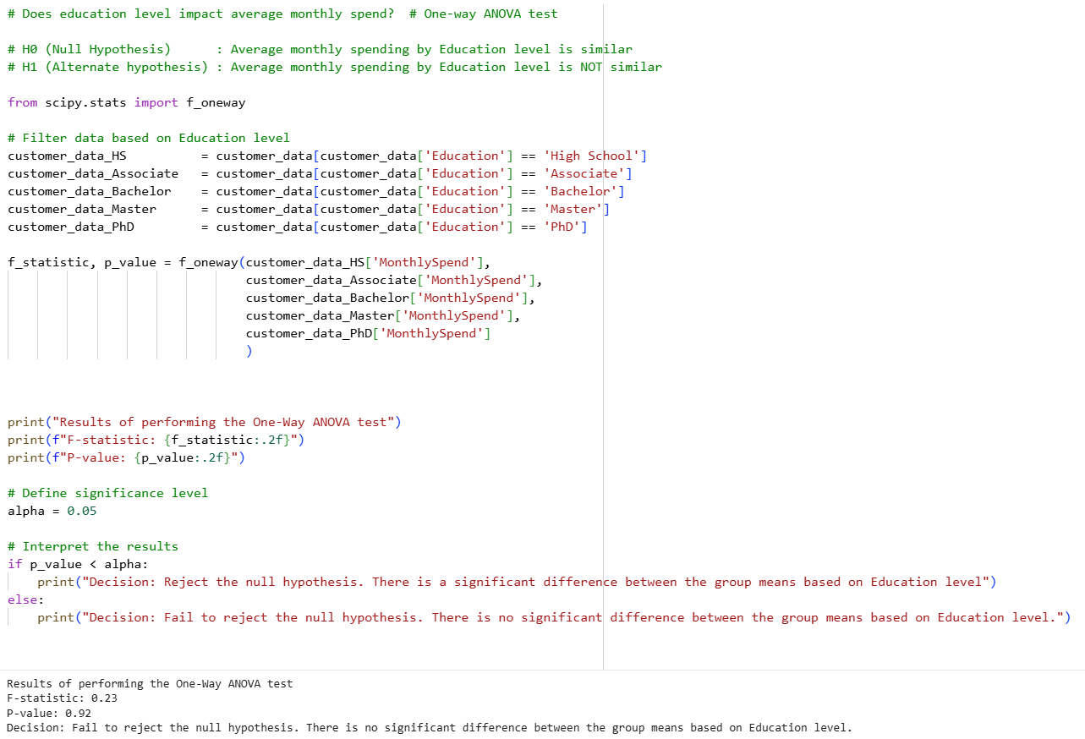
Does Education level impact average monthly spend? # One-way ANOVA test
Null Hypothesis(H₀): Average monthly spending by Education level spending is similar.
Alternate Hypothesis (H₁): Average monthly spending by Education level spending is NOT similar.

Decision: Fail to reject the null hypothesis as there is no significant difference between the group means based on Education level. P-value of 0.92 is > 0.05 and F-statistic = 0.23

=====================

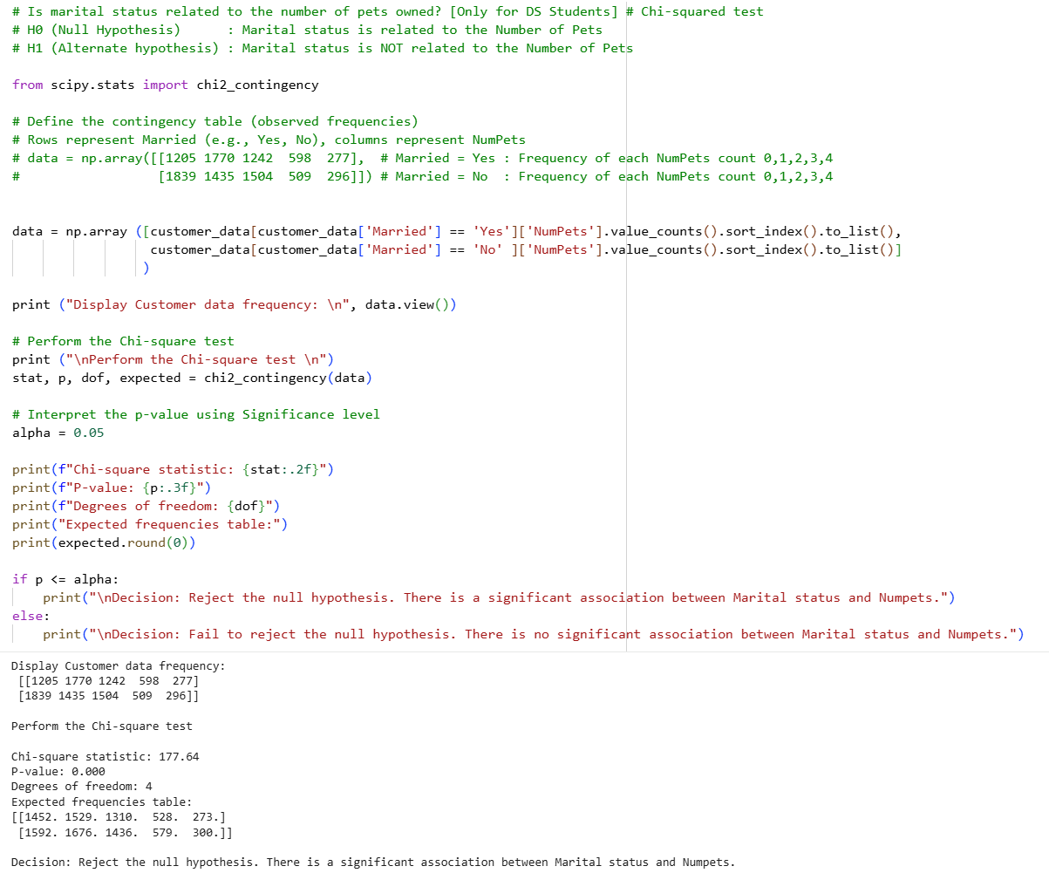
Is marital status related to the number of pets owned? [Only for DS Students] # Chi-squared test
Null Hypothesis (H₀): Marital status is related to the Number of Pets.
Alternate Hypothesis(H₁): Marital status is NOT related to the Number of Pets.

Decision: Reject the null hypothesis as there is no significant association between Marital status and Numpets. P-value of 0.00 is < 0.05

Are older people less active? #Correlation (Age vs DaysSinceLastInteraction)
Null Hypothesis (H₀): Older people are less active.
Alternative Hypothesis (H₁): There is no significant correlation between Age and the days since last interaction.

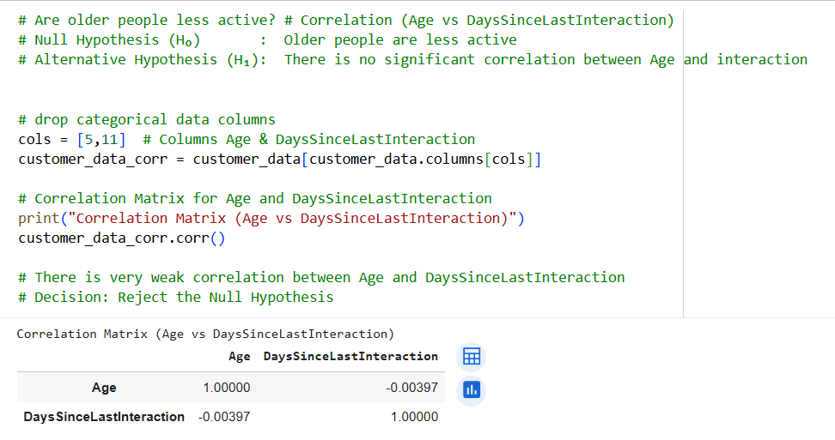

There is very weak correlation between Age and DaysSinceLastInteraction
Decision: Reject the Null Hypothesis : Older people are less active. The statistical evidence does not support it.
=====================
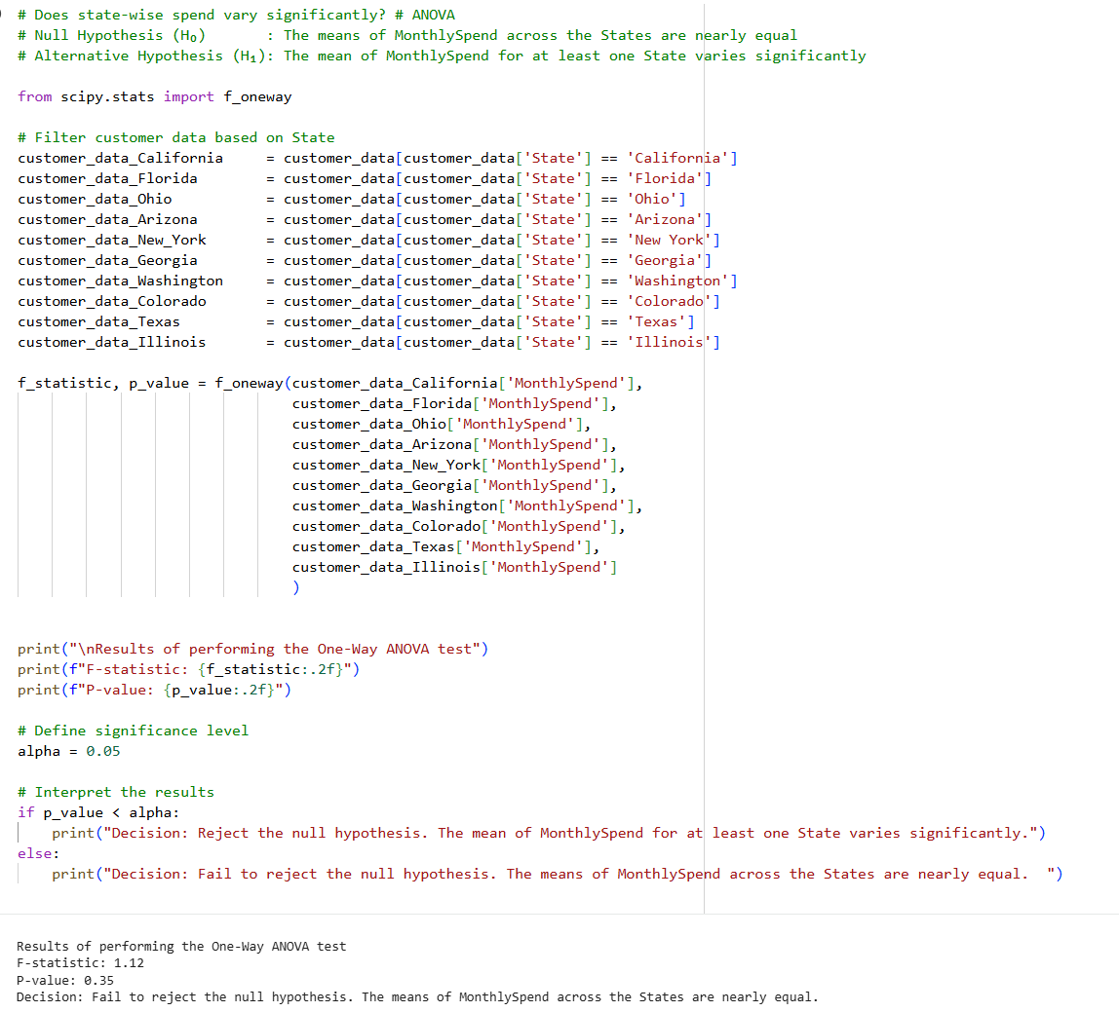

Does state-wise spend vary significantly? # ANOVA
Null Hypothesis (H₀): The means of MonthlySpend across the States are equal.
Alternative Hypothesis (H₁): The mean of MonthlySpend for at least one State varies significantly.
Decision: Fail to reject the null hypothesis as the mean of monthly spends by states is not significantly different.
P-value of 0.35 is > 0.05 . A low value of F-statistics (1.12) means there is little difference in the variances of the data by State. Accept the Null Hypothesis (H₀).
=====================
Step 7: Present Business Insights
Business Purpose: Translate stats into strategy.

Takeaways:
- The average monthly spend for Males and Females customers is similar.
- The average monthly spend by Education level of customers is similar.
- The average monthly spend by State is similar.
- Marital status of customers is NOT related to the Number of Pets.
- The correlation between Age and Days Since Last Interaction is very weak.

Strategy: The customer demographics like gender, education, age and state does not impact the monthly spend. A common marketing campaign aiming for all customer demographics can be decided.

